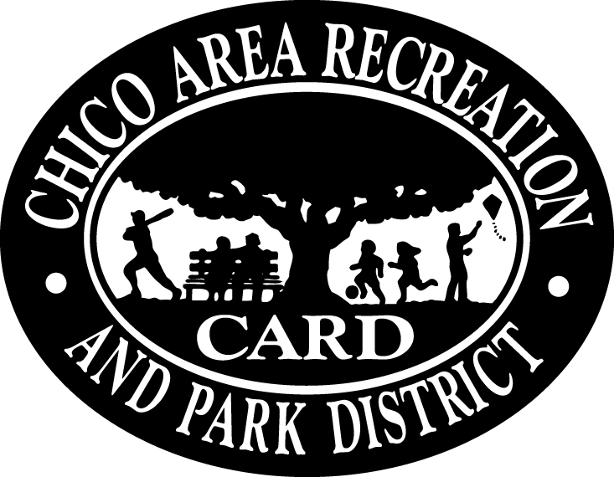
Welcome to Tiny Tots!

Welcome to Tiny Tots! My name is Leanne Miller and I am excited to start the new school year with your child! Crystal will be returning as our fantastic aide this year! I have been teaching in the field of education for over 18 years. In addition to being a credentialed elementary teacher, I have spent the last 7 years volunteering and working for the CARD Tiny Tots and Kinder Readiness programs.
Our program is designed to model and teach your child age-appropriate skills so they can confidently transition into a Pre-K program or Kindergarten. I have designed the program to make learning fun and engaging!
My philosophy of teaching is very simple. Children learn when they are safe, confident, encouraged, and challenged. I strive to provide a positive, nurturing environment that addresses each student’s individual needs. We will incorporate many learning styles while engaging all students in a fun and supportive manner.

Our Day

9:00-9:15 Cooperative Open Structure Play Time
9:15-9:40 Blue Mat Instruction
9:40-10:10 Table Work (Crafts and Related Learning Stations)
10:10-10:30 Outside Recess
10:30-10:45 Snack Time
10:45-11:00 Blue Mat Reading/Song/Movement
11:00 Dismissal

Skills We Will Practice

Sharing and teamwork
Manners, including please and thank you
Kindness
Written Name Recognition
Alphabet and Phonetic Awareness
Colors
Number Recognition and Counting to 20

Emergency Forms

Please fill out an emergency form before leaving your child for the first time. This is the form I will refer to through out the year. This form also gives others your permission to pick up your child. Update phone numbers and contact information as it changes on this form! If a person is not on this form, I cannot release your student to them. Please be prepared to show ID when picking up a child. It will be compared to the acceptable names on the emergency form.

Drop Off/Pick Up

Please sign your child in and out in the binder on the counter each day. When you have signed in, please assist your child with his or her nametag. Prompt pick-up at 11:00 is appreciated. If you are running late for any reason, please call our classroom phone. The number is 895-4709. Please note that there is no message machine attached to this line.

Snack/Helper

There will be a sign up sheet for group snack and volunteer. You do not have to volunteer and bring snack the same day, but you might find it easier to do so. It is wonderful to have one parent stay each day to assist in table work. When it is your snack day you will need to provide a healthy snack for the entire class. I will post any food allergies on the sign up sheet. Please refer to this when choosing snack. Snacks such as yogurt, string cheese, graham crackers, fruit, crackers, seem to be popular. Do not send juice or drinks. Instead, I would like each student to bring a water bottle from home to drink from at snack time. Please sign up for snack every other month. Depending on how many students are in the class, it may need to be a little more often. When it is your child’s turn to provide snack, we will sing a thank you song to them acknowledging their contribution.

Behavior Management

There are three basic rules in the Tiny Tots classroom. Be Safe. Be Respectful. Be Kind. Children at this age are just learning to interact with their peers and other adults besides their caregivers. Every conflict is a teachable moment. My aide and I will resolve conflict with discussion first. It is just as important to understand why the conflict/behavior arose, as to how it makes the individuals feel. We will use stop and think philosophy and if necessary call the parents to discuss the incident. If a child causes any injury to another child we will automatically call both parents and the child who caused the injury will be sent home.

Sharing

On most Thursdays children get a chance to bring an item from home and talk about why it is special to them. When they arrive to class they should find a cubby to store the item in until sharing time. Sharing is a special time where children get to share a personal piece of themselves. It is probably their first public speaking opportunity. Please use good judgment when helping your child choose a sharing item. Pretend weapons are never allowed.

I truly feel that teaching is a privilege. I am honored to be entrusted with your child and strive to create classroom full life-long learners. I want your child to look forward to coming each day to see what we will learn next! Please don’t hesitate to call or email with any questions, concerns, or comments. I am always open to you suggestions and thoughts. I am looking forward to a fantastic year!

Sincerely,

Leanne Miller
leannecoffman@sbcglobal.net
(530) 893-1512

