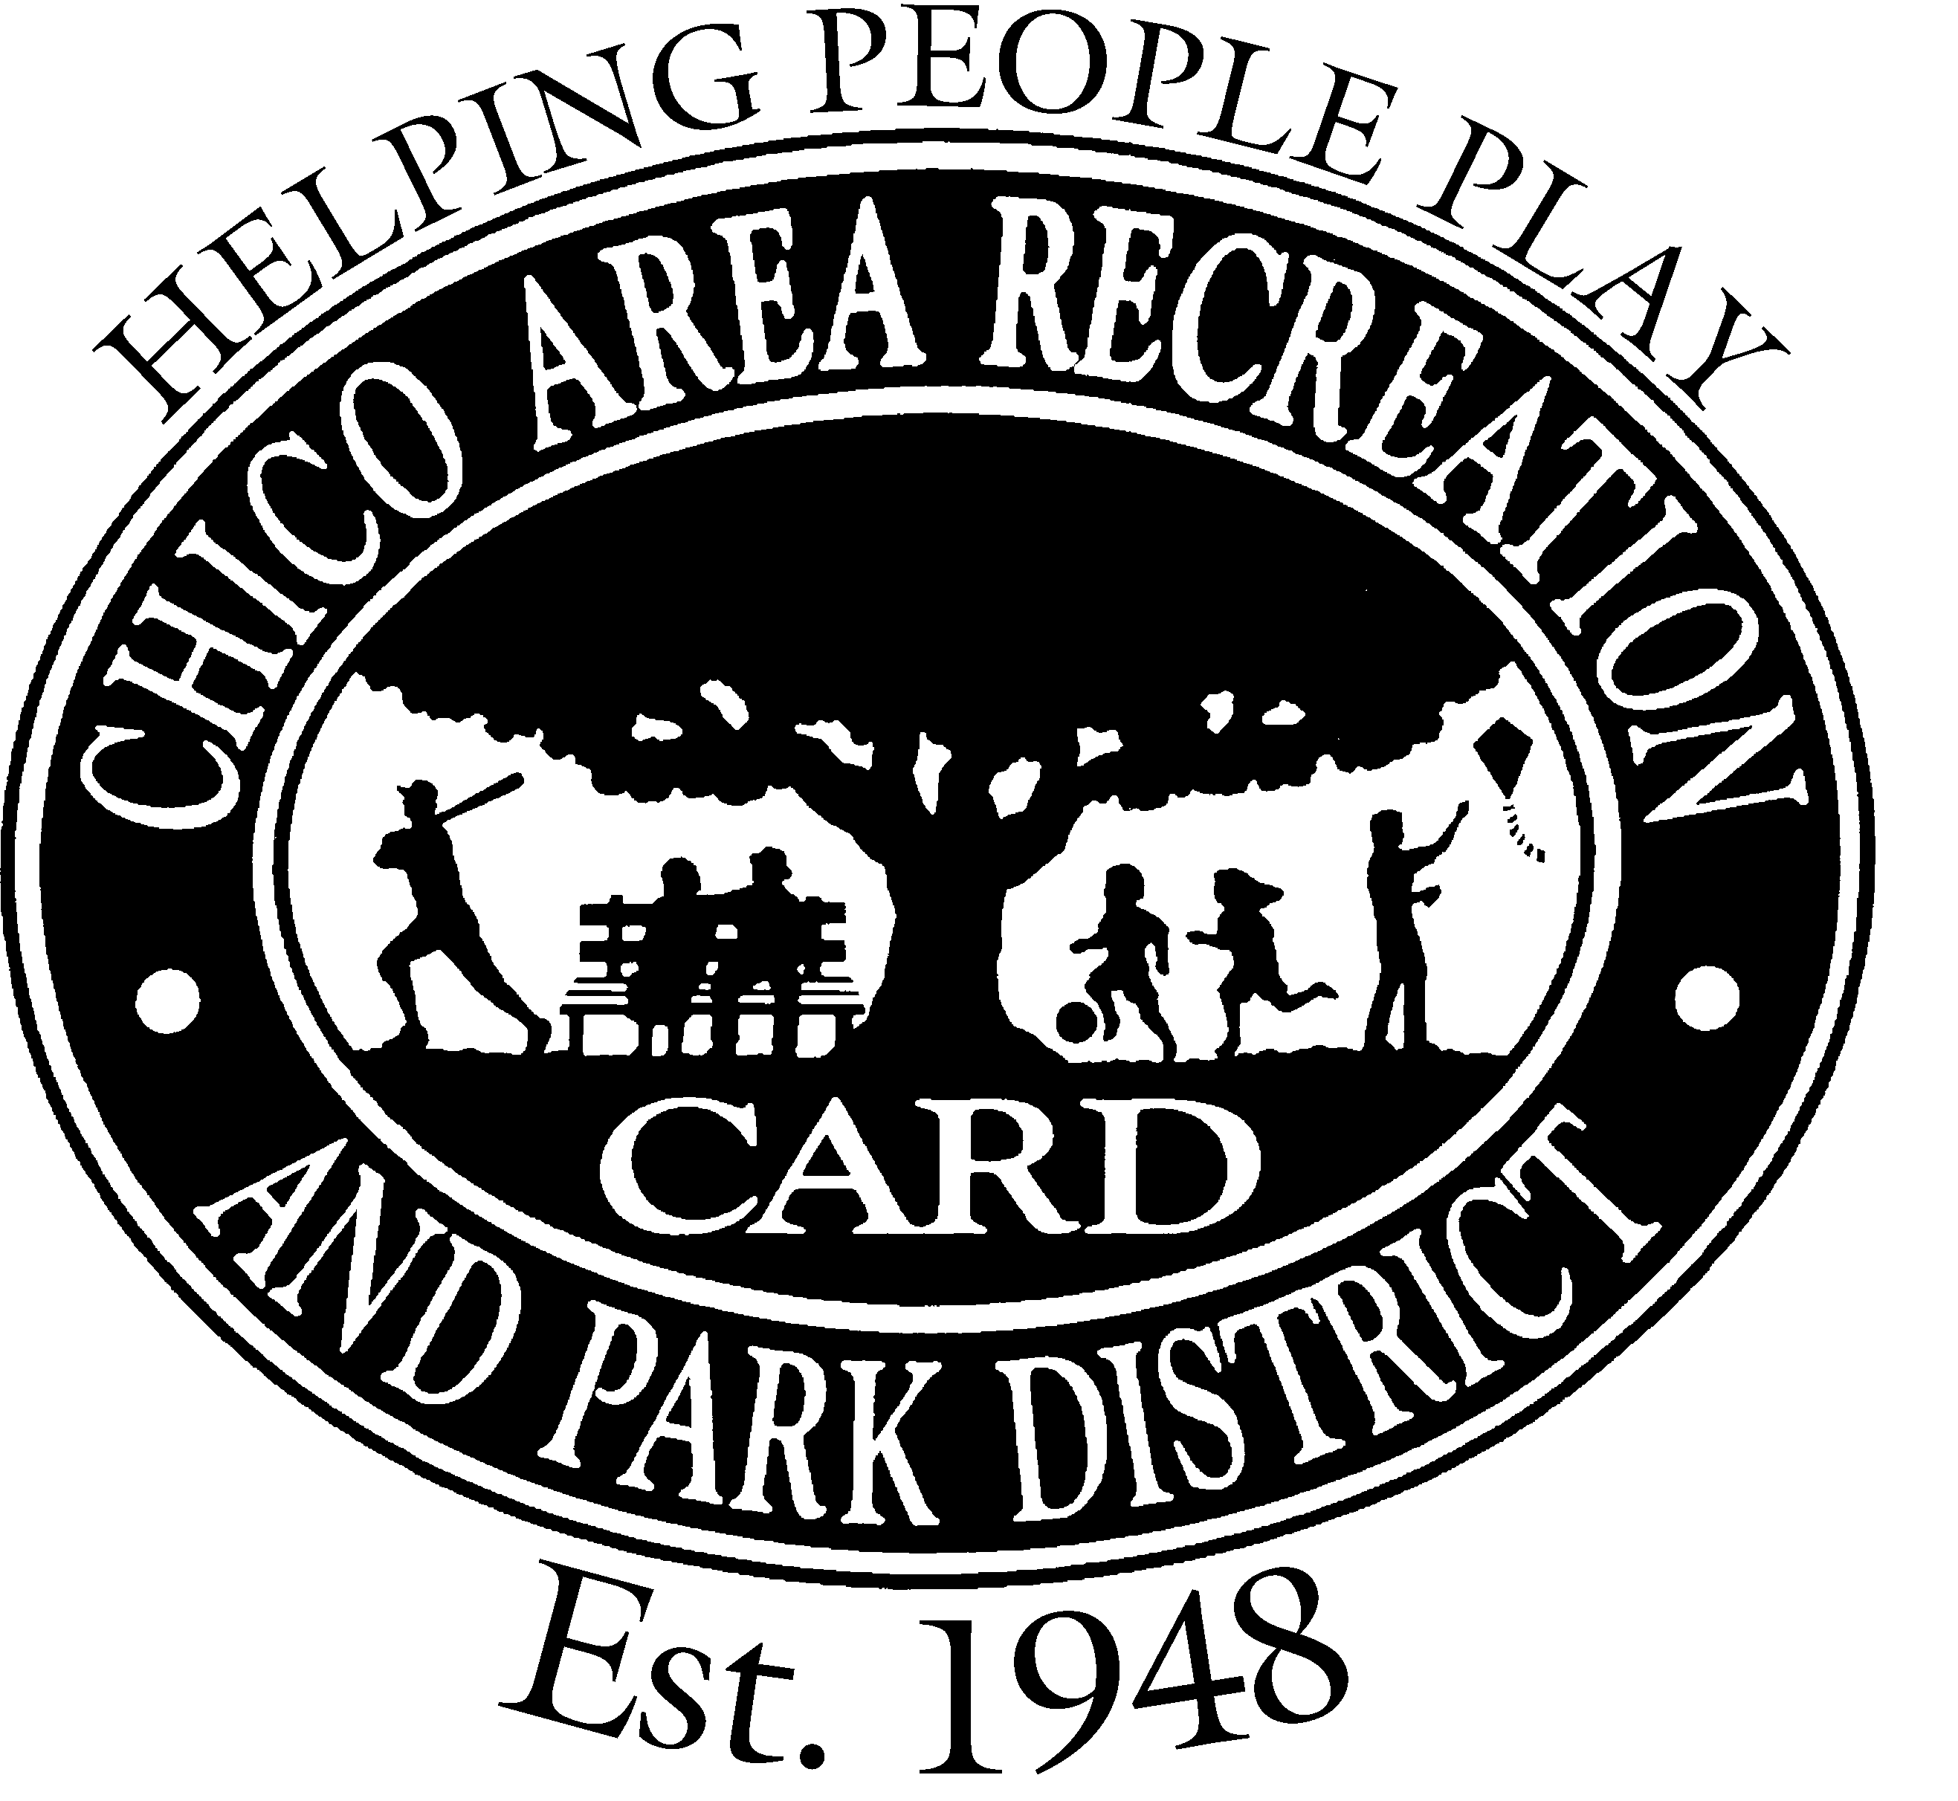
CHICO AREA RECREATION AND PARK DISTRICT
545 VALLOMBROSA AVENUE, CHICO, CA 95926
Phone (530) 895-4711 Fax (530) 895-4721
Thursday, September 22, 2022 – 4:00 PM

Posted Prior to 9:00 AM
Monday, September 19, 2022
BOARD MEMBERS: CARD STAFF:
Michael McGinnis, Chair Annabel Grimm, General Manager
Dave Donnan, Vice Chair Heather Childs, Finance Manager
Tom Lando Anjie Goulding, Recreation Manager
Michael Worley Scott Schumann, Park and Facility Manager

GENERAL INFORMATION:

1. Agendas:
Agendas are available on our website at https://www.chicorec.com/board-meetings.

2. Agenda Items:
Agenda items are available for public inspection. Staff reports and supporting documentation are available on our website at https://www.chicorec.com/board-meeting.

3. Items Not Appearing On Posted Agenda:
This agenda was posted at least 72 hours in advance of this meeting. For each item not appearing on the posted agenda upon which the Board wishes to take action, it must make one of the following determinations:

- Determine by a majority vote that an emergency exists as defined in Government Code 54956.5.
- Determine by a two-thirds vote or by a unanimous vote if less than two-thirds of the Board is present, that the need to take action arose subsequent to the agenda being posted.
- Determine that the item appeared on a posted agenda for a meeting occurring not more than five calendar days prior to this meeting, and the item was continued to this meeting.

Notwithstanding the above, items may be added to the agenda for Board discussion only or to acknowledge receipt of correspondence or other information.

- Consent Agenda: All items listed under the Consent Agenda are considered to be routine and will be enacted by one motion. Resolutions will be read by title only. There will be no separate discussion of these items unless members of the Board, or persons in the audience, request specific items to be removed from the Consent Agenda to the Regular Agenda for separate discussion, prior to the time the Board votes on the motion to adopt the Consent Agenda. If any item(s) are removed from the Consent Agenda, the item(s) will be considered at the beginning of the Regular Agenda.

- Assistance for the Disabled: If you are disabled in any way and need accommodation to participate in the meeting, please contact the CARD Office at (530) 895-4711 at least 48 hours prior to the start of the meeting so the necessary arrangements can be made.

- Identity of Speakers: Speakers are asked to state their names before speaking.

REGULAR MEETING OF THE CHICO AREA
RECREATION AND PARK DISTRICT BOARD OF DIRECTORS
Thursday, September 22, 2022 – 4:00 PM

Posted Prior to 9:00 AM
Monday, September 19, 2022
A G E N D A

1.0 CALL TO ORDER
1.1 Roll Call

2.0 CORRESPONDENCE
There is no correspondence.

3.0 PUBLIC COMMENTS
NOTE: The Chico Area Recreation and Park District Board of Directors may take official action only on items included in the posted agenda for a specific scheduled meeting. Items addressed during the Public Comment section are generally matters not included on the agenda and therefore, the Board will not take action at this scheduled meeting. However, such items may be put on the agenda for a future meeting. The public shall have the opportunity to address items that are on the posted agenda.

4.0 PRESENTATIONS
There are no presentations.

5.0 CONSENT AGENDA
5.1 Minutes of the Regular Meeting of the Board of Directors of August 25, 2022 –
Action Requested – That the Board of Directors approve the minutes as submitted.

5.2 Monthly Financial Report - Action Requested – That the Board of Directors review and approve the Monthly Financial Report.

6.0 REGULAR AGENDA
6.1 Items Removed from the Consent Agenda

7.0 UNFINISHED BUSINESS
7.1 Aquatics Facility Funding Plan (Staff report 22-102 item 4) – Information/Possible Action – Discussion about funding sources for construction and ongoing operations of new aquatics facilities.

7.2 Interviews and Appointment of Trustee Area 1 Board Member –Action Requested – That the Board of Directors interview, select, and appoint a Board Member for Trustee Area 1.

- NEW BUSINESS
  - Meriam Park Development (Staff report 22-102 item 2) – Information/Possible Action – Transfer of three Meriam Park Development parks and formation of Community Facilities (Park Maintenance) District.

9.0 BOARD OF DIRECTORS’ REPORTS/SPECIAL ASSIGNMENTS
9.1 Facilities Committee – (Staff Report 22-102) September 15, 2022 Meeting

10.0 DIRECTORS’ COMMENTS
Opportunity for the Board to comment on items not listed on the agenda.

11.0 GENERAL MANAGER’S COMMENTS
11.1 General Manager’s Update

12.0 STAFF COMMENTS
Opportunity for Staff to comment on items not listed on the agenda.

- CLOSED SESSION
13.1 Pursuant to Government Code § 54956.9, Conference with Legal Counsel – Anticipated Litigation - Potential Exposure to Litigation

- ADJOURNMENT
Adjourn to the next meeting of the Board of Directors of the Chico Area Recreation and Park District.

