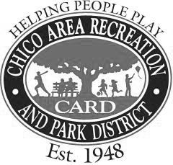
FINANCE COMMITTEE AGENDA
A Committee of the Chico Area Recreation and Park District
Board Members – Tom Lando and Michael McGinnis
545 Vallombrosa Avenue, Chico, CA 95926
Phone (530) 895-4711 Fax (530) 895-4721
Thursday, July 28, 2022 – 3:30 p.m.

Posted Prior to 8:30 am
Monday, July 25, 2022

A G E N D A

- Call to Order

- Public Comments
Members of the public may address the Committee at this time on any matter not already listed on the Agenda, with comments being limited to three minutes. The Committee cannot take any action at this meeting on requests made under this section of the agenda.

- Monthly Financial Report for June 2022 (Preliminary) - Action Requested – that the Committee recommend to the Board of Directors that they approve the Monthly Financial Report.

- Finance Policy, Purchasing Policy, Fund Balance Policy, and Capital Assets and Projects Policy - Information/Possible Action – Review and discussion about the Finance Policy, Purchasing Policy, Fund Balance Policy, and Capital Assets and Projects Policy.

- Directors’ Comments
Opportunity for the Committee to comment on items not listed on the agenda.

- Adjournment
Adjourn to the next scheduled Finance Committee Meeting.

